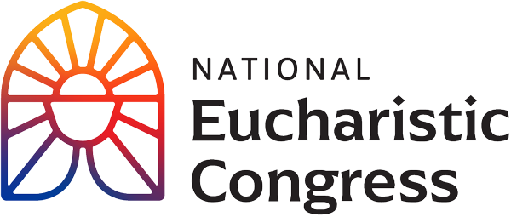

**Parish Small Groups Series**

**Catch the Fire!  
Catch the Love!**

**The Eucharist is the real and loving presence of the Lord**“The Eucharist is God’s response to the deepest hunger of the human heart, the hunger for authentic life, for in the Eucharist Christ Himself is truly in our midst, to nourish, console, and sustain us on our journey. The Holy Eucharist is more than a symbol; the Eucharist is the real and loving presence of the Lord.”  
Greeting of His Holiness Pope Francis to the Organizing Committee of the National Eucharistic Congress in the United States of America on June 19, 2023

Session 5: **“This is My Body”**

Speakers challenge us to accept our call as disciples and live the Gospel by loving God and our neighbor with all our heart.

1. **Opening Prayer**: Pray the *Our Father*, slowly and with your heart.
2. **Highlights of the Eucharistic Procession** with over 50,000 people walking through the streets of downtown Indianapolis, with benediction at the Memorial of Fallen Heroes. Participants were encouraged to line the streets along the entire route of the Eucharistic procession and then join the procession after the trailer carrying the Blessed Sacrament drove by. Before the Blessed Sacrament arrived in the procession, the people were singing, chanting, and praying aloud. The people knelt down in silent adoration as the Blessed Sacrament passed by.
3. **Jonathan Roumie** plays Jesus Christ in *The Chosen*, the first multi-season series about the life of Christ which has broken records to become the highest crowdfunded media project of all time and critically lauded.
4. **Bishop Robert Barron** is the bishop of the Diocese of Winona-Rochester, MN, and the founder of the Word on Fire Catholic Ministries. He is the host of the award-winning documentaries *CATHOLICSIM* and the more recent *CATHOLICISM: The Pivotal Players*. Bishop Barron is a #1 Amazon bestselling author.
5. **Adoration of the Blessed Sacrament, that includes an opening procession, a time of praising God with music, Benediction and closing procession.**Praising God with music withMatt Maher and Sarah Kreager leading.

**Silent reflection during Adoration**  
During the period of adoration, there are three periods with five minutes of silent reflection. There are questions for personal reflection on the song sheet for two of these 5 minute periods of silence, and the third period of silence is for the person to rest in Jesus. You are invited to write down your responses below to these questions.

1. **Closing Prayer in church (if convenient)**

“Holy Spirit, come! Lead us to all truth. Grant us a faith that is not afraid to be bold. Enkindle in us a flame of hope that sets our hearts ablaze with love for You. Father, in the Name of Jesus, we ask that You would raise up saints, prophets, and martyrs to meet the needs of our day, and may we be numbered among them. Amen.”

If you would like to re-watch a segment or the entire session, visit [**https://diolc.org/eucharist/parishioners**](https://diolc.org/eucharist/parishioners). Click the **Video:** July 20 Revival Session. Videos are free.