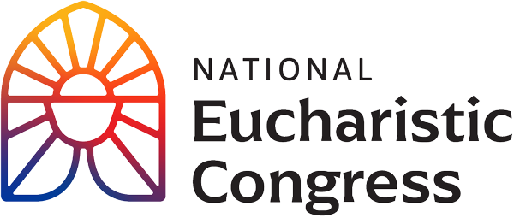

**Parish Small Groups Series**

**Catch the Fire!  
Catch the Love!**

**The Eucharist is the real and loving presence of the Lord**“In the Eucharist, we encounter the One Who gave everything for us, Who sacrificed Himself in order to give us life, Who loved us to the end. We become credible witnesses to the joy and transforming beauty of the Gospel only when we recognize that the love we celebrate in this Sacrament cannot be kept to ourselves but demands to be shared with all.”  
Greeting of His Holiness Pope Francis to the Organizing Committee of the National Eucharistic Congress in the United States of America on June 19, 2023

Session 6: **“To the Ends of the Earth”**Speakers inspire hope for God’s plan in this historic Year of Mission, and explain how to be part of this exciting new chapter.

1. **Opening Prayer**: Pray the *Our Father* very slowly, from the heart.
2. **Interview with permanent pilgrims** who walked on the Eucharistic pilgrimage from the four corners of the United States.
3. **Chris Stefanick** is one of the most engaging defenders of the Christian faith on the scene today. His TV shows, videos and radio spots reach millions of people. Chris is also the founder of Real Life Catholic.
4. **Personal Testimony** by a young woman.
5. **Mother Adela Galinda** was born in Nicaragua and later moved to the United States. She founded a bilingual religious family: Servants of the Pierced Hearts of Jesus and Mary Religious Sisters, Brothers and Priests, and Lay Apostles of the Pierced Hearts.
6. **Opening Song and Procession of Mass**

Join with the Indianapolis Symphony and Chamber Choir sing “Alleluia Sing to Jesus”

1. **Amazing Homily by Cardinal Tagle, Special Papal Delegate from the Vatican in Rome**.
2. **Small Group Discussion**

-What was the most important point for you from what you have seen thus far? Why did this seem to stand out for you? In light of this, write down something that you would want to pass on to a family member or friend?  
-From this takeaway of what moved you the most, how can you use this to help deepen your relationship with Jesus? In other words, in your daily prayer life, what small addition can you add or adjust that is doable and sustainable? (such as good spiritual reading, one page a day, or a weekly 5 min. visit to the Blessed Sacrament for a personal conversation with Jesus).

1. **Closing Prayer in church (if convenient)**

“Holy Spirit, come! Lead us to all truth. Grant us a faith that is not afraid to be bold. Enkindle in us a flame of hope that sets our hearts ablaze with love for You. Father, in the Name of Jesus, we ask that You would raise up saints, prophets, and martyrs to meet the needs of our day, and may we be numbered among them. Amen.”

If you would like to re-watch a segment or the entire session, visit [**https://diolc.org/eucharist/parishioners**](https://diolc.org/eucharist/parishioners). Click the **Video:** July 21 Revival Session.