**DIVINE MERCY**

**Chaplet and Novena**

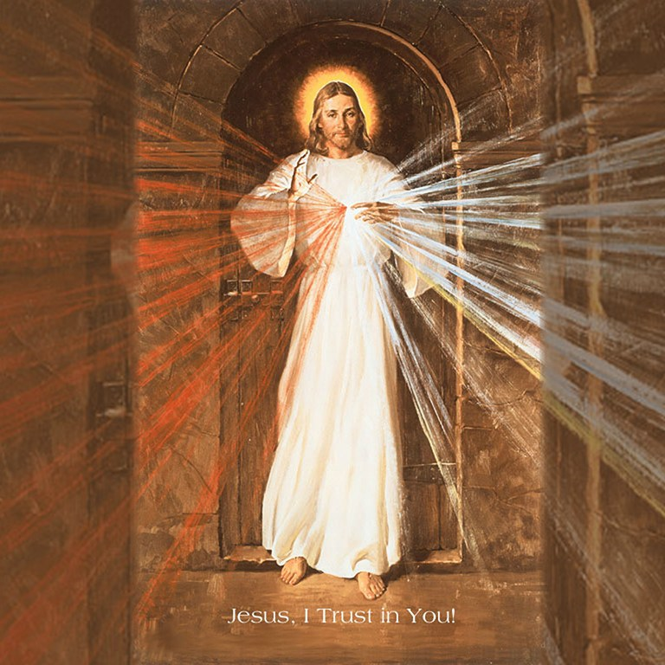

**DIVINE MERCY SUNDAY IS THE  
 SUUNDY AFTER EASTER. BEGIN THE NOVENA ON *GOOD FRIDAY.***

In Our Lord’s revelations to St. Faustina, He asked for a special prayer

and meditation on His Passion each afternoon at the three o-clock

hour, the hour that recalls His death on the cross, also called the hour

of great mercy. This prayer is known as the **Chaplet of Divine Mercy**.

Jesus said, “At three o-clock, implore My mercy, especially for sinners;

and, if only for a brief moment, immerse yourself in My Passion,

particularly My abandonment at the moment of agony. This is the

hour of great mercy. In this hour, I will refuse nothing to the soul that

makes a request of Me in virtue of My Passion.” (Diary, 1320)

Our Lord also told St. Faustina, “It is my desire that the Feast of Mercy

be solemnly celebrated on the first Sunday after Easter.” This day is also known as **Divine Mercy Sunday.**

To fittingly observe the Feast of Mercy, we should:  
1. Celebrate the Feast on the first Sunday after Easter (or its Vigil)

2. Sincerely repent of all our sins.

3. Place our complete trust in Jesus.

4. Go to Confession, preferably before the Feast.

5. Receive Holy Communion on the day of the Feast. (or Vigil)

6. Venerate the Image of the Divine Mercy.

**WHY RECITE THE CHAPLET, PRAY THE NOVENA AND CELEBRATE DIVINE MERCY SUNDAY? Extraordinary Graces**

The Message of the Divine Mercy that St. Faustina received from the Lord records a special promise given to her by Jesus. **“My daughter, tell the whole world about My inconceivable mercy. I desire that the Feast of Mercy be a refuge and shelter for all souls, and especially for poor sinners. I pour out a whole ocean of graces upon those souls who approach the fount of My mercy.”** (699) St. Faustina records our Lord’s promises of specific, extraordinary graces for those who observe Divine Mercy Sunday: **“The soul that will go to Confession and receive Holy Communion will obtain complete forgiveness of sins and punishments.”** said Jesus. (699)

**HOW TO RECITE THE CHAPLET OF DIVINE MERCY**

The Chaplet of Mercy is recited using ordinary Rosary Beads.

**1. Make the Sign of the Cross**

**2. Optional Opening Prayer**

You expired, Jesus, but the source of life gushed fourth for souls, and the ocean of mercy opened up for the whole world. O Fount of Life, unfathomable Divine Mercy, envelope the whole world and empty Yourself out upon us.

(Repeat three times) O Blood and Water, which gushed forth from the Heart of Jesus as a fountain of Mercy for us, I trust in You!

**3. Our Father**

**4. Hail Mary**

**5. The Apostles’ Creed**

**6. The Eternal Father**

Eternal Father, I offer you the Body and Blood, Soul and Divinity of Your Dearly Beloved Son, Our Lord, Jesus Christ, in atonement for our sins and those of the whole world.

**7. On the Ten Small Beads of Each Decade**

For the sake of His sorrowful Passion, have mercy on us and on the whole world.

**8. Repeat for the remaining decades**

Saying the “Eternal Father (6) on the “Our Father” bead and then 10 “For the sake of His Sorrowful Passion” (7) on the “Hail Mary” Beads.

**9. Conclude with the Holy God** (Repeat three times)   
Holy God, Holy Mighty one, Holy Immortal One, have mercy on us and

on the whole world.

**10. Optional Closing Prayer**

Eternal God, in whom mercy is endless and the treasury of compassion inexhaustible, look kindly upon us and increase Your mercy in us, that in difficult moments we might not despair nor become despondent, but with great confidence submit ourselves to Your holy will, which is Love and Mercy itself.

**NOVENA (to begin on Good Friday)**

**First Day**

*Today bring ME ALL MANKIND, ESPECIALLY ALL SINNERS, and immerse them in the ocean of My mercy. In this way you will console Me in the bitter grief into which the loss of souls plunges Me.*

Most Merciful Jesus, whose very nature it is to have compassion on us and to forgive us, do not look upon our sins but upon our trust which we place in Your infinite goodness. Receive us all into the abode of Your Most Compassionate Heart and never let us escape from It. We beg this of You by Your love which unites You to the Father and the Holy Spirit.

Eternal Father, turn Your merciful gaze upon all mankind and especially upon poor sinners, all enfolded in the Most Compassionate Heart of Jesus. For the sake of His Sorrowful Passion show us Your mercy, that we may praise the omnipotence of Your mercy forever and ever.   
(Recite Chaplet of Divine Mercy)

**Second Day**

*Today bring to Me THE SOULS OF PRIESTS AND RELIGIOUS, and immerse them in My unfathomable mercy. It was they who gave Me strength to endure My bitter passion. Through them, as through channels, My Mercy flows out upon mankind.*

Most Merciful Jesus, from who comes all that is good, increase Your grace in men and women consecrated to Your service, that they may perform worthy works of mercy; and that all who see them may glorify the Father of Mercy who is in heaven.

Eternal Father, turn Your merciful gaze upon the company of chosen ones in Your vineyard – upon the souls of priests and religious; and endow them with the strength of Your blessing. For the love of the Heart of Your Son in which they are enfolded, impart to them Your power and light, that they may be able to guide others in the way of salvation and with one voice sing praise to Your boundless mercy for ages without end. (Recite Chaplet)

**Third Day**

*Today bring to Me ALL DEVOUT AND FAITHFUL SOULS, and immerse them in the ocean of My mercy. The souls brought Me consolation on the Way of the Cross. They were that drop of consolation in the midst of*

*an ocean of bitterness.*

Most Merciful Jesus, from the treasury of Your Mercy, You impart Your

graces in great abundance to each and all. Receive us into the abode

of Your Most Compassionate Heart and never let us escape from It.

We beg this grace of You by that most wonderous love for the

Heavenly Father with which Your Heart burns so fiercely.

Eternal Father, turn Your merciful gaze upon faithful souls, as upon the

inheritance of Your Son. For the sake of His Sorrowful Passion, grant

them Your blessing and surround them with Your constant protection.

Thus may they never fail in love or lose the treasure of the holy faith,

but rather, with all the hosts of Angels and Saints, may they glorify You

boundless mercy for endless ages. (Reite Chaplet)

**Fourth Day**

*Today bring to Me THOSE WHO DO NOT BELIEVE IN GOD AND THOSE*

*WHO DO NOT YET KNOW ME. I was thinking also of them during My*

*bitter Passion, and their future zeal comforted My Heart. Immerse*

*them in the ocean of My mercy.*

Most compassionate Jesus, You are the Light of the whole world.

Receive into the abode of Your Most Compassionate Heart the souls

of those who do not believe in God and of those who as yet do not

know You. Let the rays of Your grace enlighten them that they, too,

together with us, may extol Your wonderful mercy; and do not let

them escape from the abode of Your Most Compassionate Heart.

Eternal Father, turn Your merciful gaze upon the souls of those who do

not believe in You, and of those who as yet do know You, but who are

enclosed in the Most Compassionate Heart of Jesus. Draw them to the

light of the Gospel. These souls do not know what great happiness it is

to love You. Grant that they, too, may extol the generosity of Your

mercy for endless ages. Amen. (Recite Chaplet)

**Fifth Day**

*Today bring to Me THE SOULS OF THOSE WHO HAVE SEPARATED*

*THEMSELVES FROM MY CHURCH, and immerse them into the ocean of*

*My mercy. During My bitter Passion they tore at My Body and Heart,*

*that is My Church. As they return to unity with the Church, My wounds*

*heal and in this way they alleviate My Passion.*

Most Merciful Jesus, Goodness Itself, You do not refuse light to those

who seek it of You. Receive into the abode of Your Most

Compassionate Heart the souls of those who have separated

themselves from Your Church. Draw them by Your light into the unity

of the Church, and do not let them escape from the abode of Your

Most Compassionate Heart; but bring it about that they, too, come to

glorify the generosity of Your mercy.

Eternal Father, turn Your merciful gaze upon the souls of those who

have separated themselves from Your Son’s Church, who have

squandered Your blessings and misused Your graces by obstinately

persisting in their errors. Do not look upon their errors, but upon the love of Your own Son and upon His bitter Passion, which He   
underwent for their sake, since they, too, are enclosed in His Most

Compassionate Heart. Bring it about that they also may glorify Your great mercy for endless ages. (Recite Chaplet)

**Sixth Day**

*Today bring to Me THE MEEK AND HUMBLE SOULS AND THE SOULS OF LITTLE CHILDREN, and immerse them in My mercy. These souls most closely resemble My Heart. They strengthened Me during My bitter agony. I saw them as earthly Angels, who will keep vigil at My altars. I pour out upon them whole torrents of grace. Only the humble soul is capable of receiving My grace. I favor humble souls with My confidence.*

Most Merciful Jesus, You Yourself have said, “Learn from Me for I am meek and humble of heart.” Receive into the abode of Your Most Compassionate Hearth all meek and humble souls and the souls of little children. These souls send all heaven into ecstasy and they are the heavenly Father’s favorites. They are a sweet-smelling bouquet before the throne of God; God Himself takes delight in their fragrance. These souls have a permanent abode in Your Most Compassionate Heart, O Jesus, and they unceasingly sing out a hymn of love and mercy.

Eternal Father, turn Your merciful gaze upon meek souls. Upon humble souls, and upon little children who are enfolded in the abode which is the Most Compassionate Heart of Jesus. These souls bear the closest resemblance to Your Son. Their fragrance rises from the earth and reaches Your very throne. Father of mercy and of all goodness, I beg You by the love You bear these souls and by the delight You take in them: Bless the whole world, that all souls together may sing out the praises of Your mercy for endless ages. (Recite Chaplet)

**Seventh Day**

*Today bring to Me THE SOULS WHO ESPECIALLY VENERATE AND GLORIFY MY MERCY, and immerse them in My mercy. These souls sorrowed most over my Passion and entered most deeply into My spirit. They are living images of My Compassionate Heart. These souls will shine with a special brightness in the next life. Not one of them will go into the fire of hell. I shall particularly defend each one of them at the hour of death.*

Most Merciful Jesus, whose Heart is Love Itself, receive into the abode of Your Most Compassionate Heart the souls of those who particularly extol and venerate the greatness of Your mercy. These souls are mighty with the very power of God Himself. In the midst of all afflictions and adversities they go forward, confident of Your mercy; and united to You, O Jesus, they carry all mankind on their shoulders. These souls will not be judged severely, but Your mercy will embrace them as they depart from this life.

Eternal Father, turn Your merciful gaze upon the souls who glorify and venerate Your greatest attribute, that of Your fathomless mercy, and who are enclosed in the Most Compassionate Heart of Jesus. These souls are a living Gospel; their hands are full of deeds of mercy, and

their hearts, overflowing with joy, sing a canticle of mercy to You, O Most High! I beg You O God: Show them Your mercy according to the

hope and trust they have placed in You. Let there be accomplished in them the promise of Jesus, who said to them that during their life, but especially at the hour of death, the souls who will venerate this fathomless mercy of His, He, Himself, will defend as His glory.   
(Recite Chaplet)

**Eight Day**

*Today bring to Me THE SOULS WHO ARE DETAINED IN PURGATORY and immerse them in the abyss of My mercy. Let the torrents of My Blood cool down their scorching flames. All these souls are greatly loved by Me. They are making retribution to My Justice. It is in our power to bring them relief. Draw all the indulgences from the Treasury of My Church and offer them on their behalf. Oh, if you only knew the torments they suffer, you would continually offer for them the alms of the spirit and pay off their dept to My justice.*

Most Merciful Jesus, You Yourself have said that You desire mercy; so I bring into the abode of Your Most Compassionate Heart the souls in Purgatory, souls who are very dear to You, and yet, who must make retribution to Your Justice. May the streams of Blood and Water which gushed forth from Your Heart put out the flames of Purgatory, that there, too, the power of Your mercy may be celebrated.

Eternal Father, turn Your Merciful gaze upon the souls suffering in Purgatory, who are enfolded in the Most Compassionate Heart of Jesus. I beg You, by the sorrowful Passion of Jesus Your Son, and by all the bitterness with which His most sacred Soul was flooded: Manifest Your mercy to the souls who are under Your just scrutiny. Look upon them in no other way but only through the Wounds of Jesus, Your dearly beloved Son; for we firmly believe that there is no limit to Your goodness and compassion. (Recite Chaplet)

**Ninth Day**

*Today bring to Me SOULS WHO HAVE BECOME LUKEWARM, and immerse them in the abyss of My mercy. These souls wound my Heart most painfully. My soul suffered the most dreadful loathing in the Garden of Olives because of lukewarm souls. They were the reason I cried out: ‘Father, take this cup away from Me, if it be Your will.” For them, the last hope of salvation is to run to My mercy.*

Most Compassionate Jesus, You are Compassion Itself. I bring lukewarm souls into the abode of Your Most Compassionate Hearth. In this fire of Your pure love, let these tepid souls, who, like corpses, filled You with such deep loathing, be once again set aflame. O Most Compassionate Jesus, exercise the omnipotence of Your mercy and draw them into the very ardor of Your love, and bestow upon them the gift of holy love, for nothing is beyond Your power.

Eternal Father, turn Your merciful gaze upon lukewarm souls who are nonetheless enfolded in the Most Compassionate Heart of Jesus. Father of Mercy, I beg You by the bitter Passion of Your Son and by His three-hour agony on the Cross: Let them, too, glorify the abyss of Your Mercy. (Recite Chaplet) V**isit www.thedivinemercy.org**