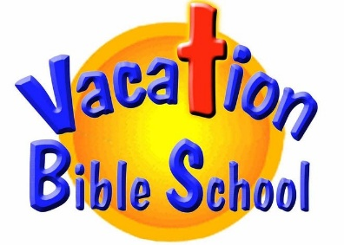

**St. Mary’s in Viroqua and the area parishes are hosting a Vacation Bible School**

**What:** Bible program for grades K-6

**Where:** 400 Congress Avenue, Viroqua, WI 54665

**When:** Monday, June 30-Thursday July 3 from 9AM - Noon

conducted by the Dominican Sisters of Mary Mother of the Eucharist

**Schedule**

|  |  |
| --- | --- |
| **Monday**  8:30 AM Mass, 9:00-12:00 Programming in Viroqua  6:30 PM Evening Mission at St. Mary’s in Gays Mills | **Tuesday**  8:30 AM Mass, 9:00-12:00 Programming in Viroqua  6:30 PM Evening Mission at St. Charles in Genoa |
| **Wednesday**  8:30 AM Mass, 9:00-12:00 Programming in Viroqua  6:30 PM Evening Mission & Soup Supper at Viroqua | **Thursday**  8:30 AM Mass, 9:00-12:00 Programming in Viroqua  6:30 PM Evening Mission at Sacred Heart in Cashton |
| **Friday**  Families are welcome to pack a lunch and join the Dominican Sisters at Our Lady of Guadalupe Shrine, 5250 Justin Road  11:30 AM – meet outside the church; 11:45 Rosary Walk; 1:00 Mass; 3:00 Divine Mercy Chaplet | |

**To Register by June 27, scan the code at the top or go to** [**https://forms.gle/ejUGQSbBxFGjggBUA**](https://forms.gle/ejUGQSbBxFGjggBUA),

**Contact** [**StMaryFormation@mwt.net**](mailto:StMaryFormation@mwt.net) **with any questions, or call Pat at 262-822-1850**